Practical – 5

Practical Title: Registration Form with Frontend Validation and User-Friendly Error Handling

Problem Definition: Create a student registration form with HTML5 input types and JavaScript validation for name, email, mobile number, password, confirm password, course, year, gender, and terms acceptance. Use Regular Expression for validations.

Theory
References for all questions:

https://developer.mozilla.org/en-US/docs/Web/HTML/Reference/Elements/input?

1. Are correct input types and attributes used?
Answer: Yes, correct input types like text, email, tel and password are used with required and pattern attributes.

2. Are validation errors displayed near the relevant fields?
Answer: Yes, error messages are displayed near the field where the mistake occurs.

3. Is password strength checked?
Answer: Yes, the password is checked for minimum length, uppercase, lowercase, number and special character.

4. Is the form accessible using keyboard and screen-reader-friendly labels?
Answer: Yes, proper labels are used and the form can be accessed using the keyboard.

Implementation/ Output/Result
The registration form was created using HTML and JavaScript.
JavaScript was used to check the user details.
Errors are shown when incorrect details are entered.
The registration form was successfully created and validated.

Evidence of Work (Screenshots)

Description: Figure 5.1 Registration Page


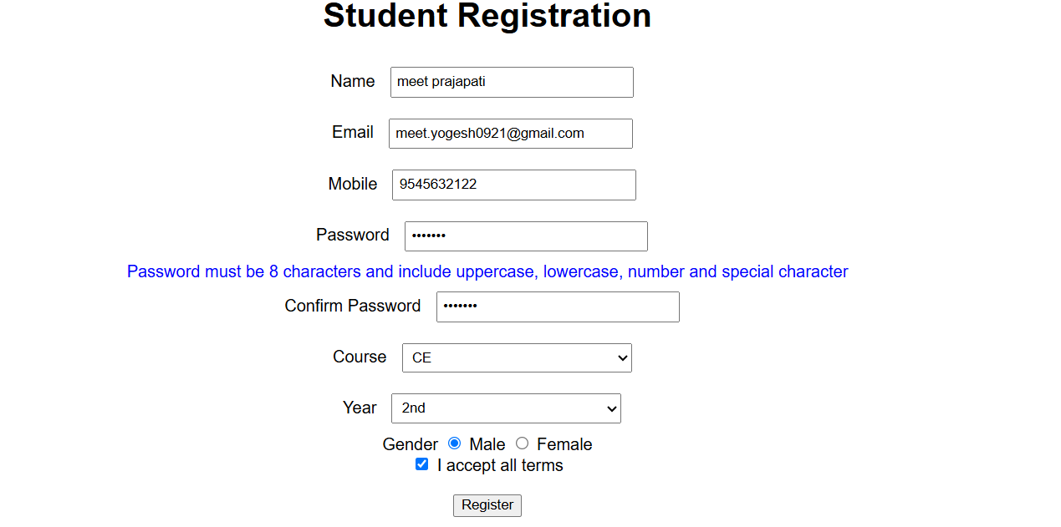
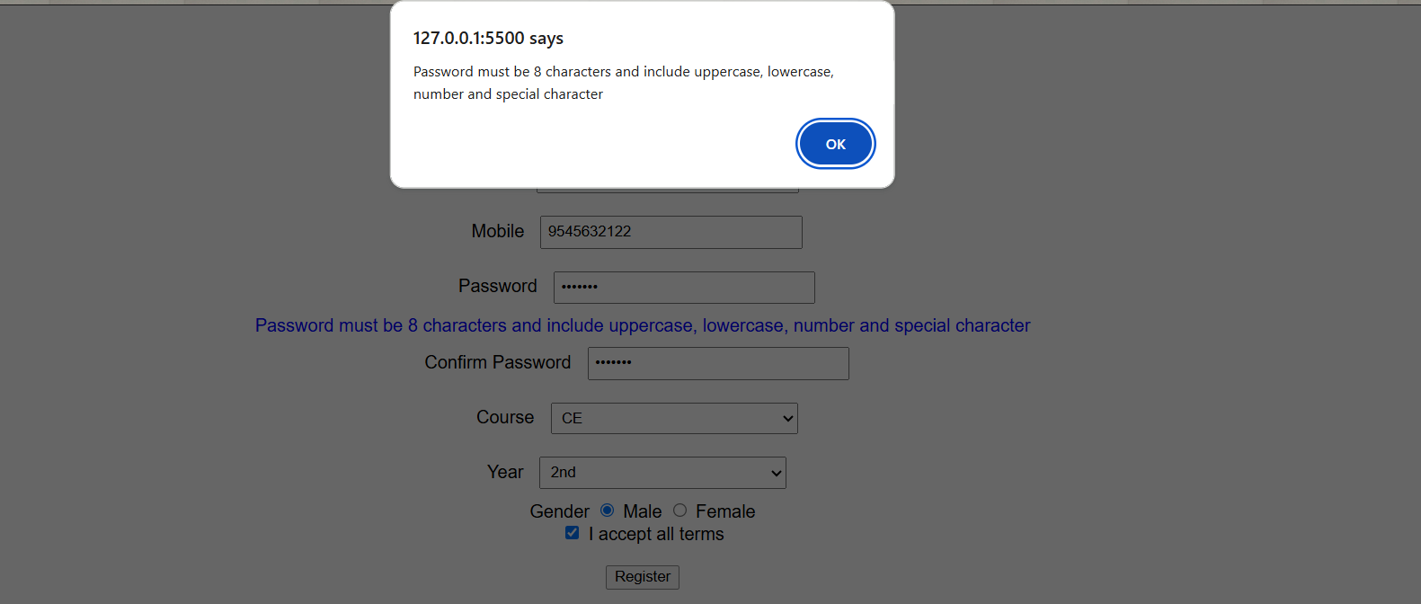

D. GitHub Repository Link:
Link: https://github.com/meetp2m/WDF-PRACTICAL-5

Challenges Faced:

Answer: The main challenge was understanding JavaScript validation.
I faced some difficulty in checking the password and confirm password.

F. Learning Outcomes:

Answer: I learned how to create a student registration form using HTML.
I learned how to validate user input using JavaScript.

G. Faculty Remarks:

